EXPT NO:5A | DATA VISUALIZATION USING MATPLOTLIB – SALES DATA

Aim:
To visualize dataset features and distributions using line charts, bar charts, pie charts, histograms, scatter plots, and box plots using Matplotlib.

Algorithm:

ALGORITHM 1: LINE CHART
Objective: To visualize the monthly sales trend.

Steps
- Load the sales dataset.
- Select the Month and Sales columns.
- Plot the monthly sales using a line chart.
- Add title and axis labels.
- Display the graph.

Interpretation
The line chart shows how sales vary across different months and helps identify the sales trend. # Program 1: Line Chart
plt.plot(months, sales) plt.title("Monthly Sales") plt.xlabel("Months") plt.ylabel("Sales") plt.show()

ALGORITHM 2: BAR CHART
Objective: To compare sales across different months.

Steps
- Select the Month and Sales columns.
- Create a bar chart using the monthly sales values.
- Add title and axis labels.
- Display the chart.

Interpretation
The bar chart helps compare the sales values across different months. # Program 2: Bar Chart plt.bar(months, sales)
plt.title("Monthly Sales") plt.xlabel("Months") plt.ylabel("Sales") plt.show()

ALGORITHM 3: PIE CHART
Objective: To visualize the distribution of sales across different months.

Steps
- Select the sales values.
- Create a pie chart using the sales values.
- Display percentage labels.
- Add a suitable title.
- Display the chart.

Interpretation
The pie chart shows the percentage contribution of each month to the total sales. # Program 3: Pie Chart
plt.pie(sales, labels=months,

ALGORITHM 4: HISTOGRAM
Objective: To visualize the distribution of sales values.

Steps
- Select the Sales column.
- Divide the sales values into bins.
- Create a histogram.
- Add title and axis labels.
- Display the histogram.

Interpretation
The histogram shows the frequency distribution of the monthly sales values. # Program 4: Histogram plt.hist(sales, bins=5)
plt.title("Sales Distribution") plt.xlabel("Sales") plt.ylabel("Frequency") plt.show()

ALGORITHM 5: SCATTER PLOT
Objective: To visualize the sales values for different months.

Steps
- Select Month as the X-axis variable.
- Select Sales as the Y-axis variable.
- Create a scatter plot.
- Add title and axis labels.
- Display the graph.

Interpretation
The scatter plot shows the variation in sales across different months. # Program 5: Scatter Plot

ALGORITHM 6: BOX PLOT
Objective: To visualize the distribution of monthly sales.

Steps
- Select the Sales column.
- Create a box plot.
- Add a suitable title and axis label.
- Display the plot.

Interpretation
The box plot shows the distribution of sales values and helps identify possible outliers. # Program 6: Box Plot plt.boxplot(sales)
plt.title("Sales Box Plot") plt.ylabel("Sales") plt.show()

ALGORITHM 7: MULTIPLE LINE CHARTS
Objective: To compare sales and profit across different months.

Steps
- Store the profit values.
- Plot the sales values using a line chart.
- Plot the profit values using another line chart.
- Add title, axis labels and legend.
- Display the graph.

Interpretation
The multiple line chart compares the sales and profit values across different months. # Program 7: Multiple Line Charts
profit = [20, 30, 40, 35, 50, 60]

plt.plot(months, sales, label="Sales") plt.plot(months, profit, label="Profit")
plt.title("Sales and Profit") plt.xlabel("Months") plt.ylabel("Value") plt.legend() plt.show()

Output:

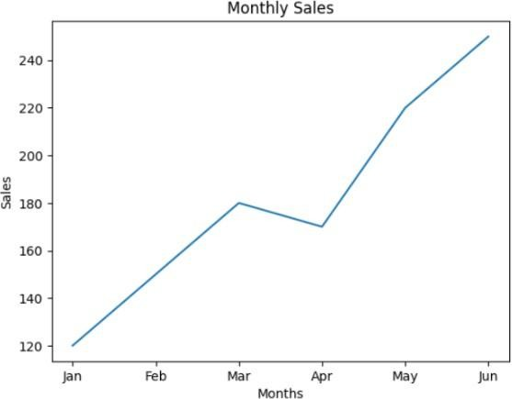

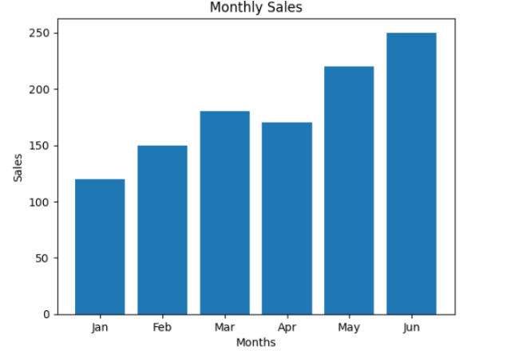
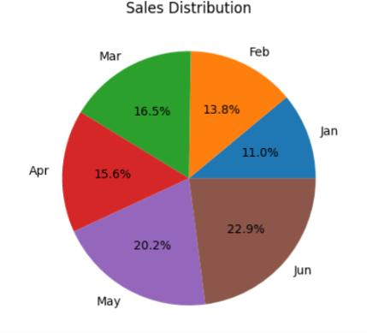

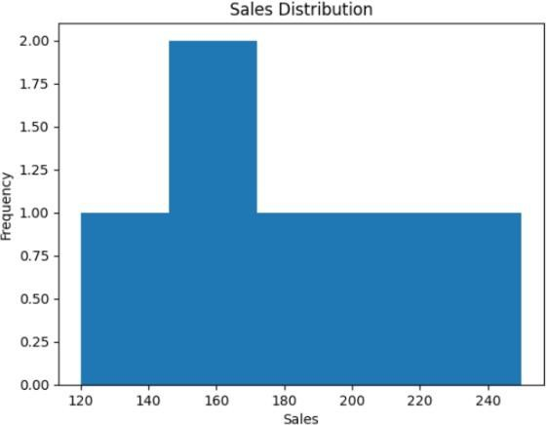

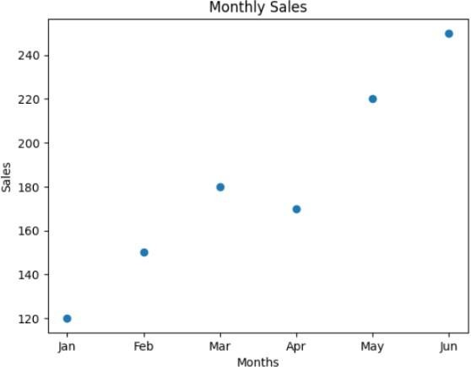

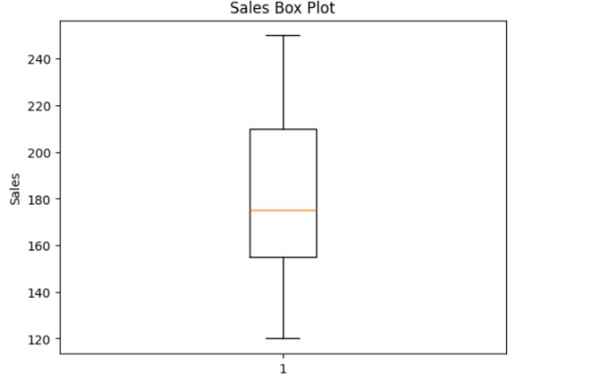

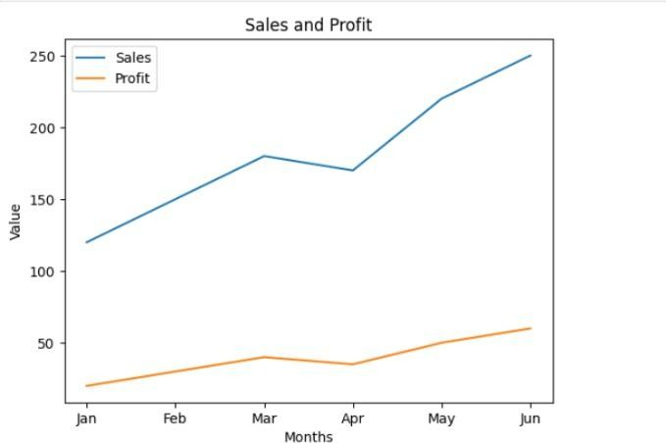

Result:

EXPT NO:5B | DATA VISUALIZATION

AIM:
To visualize the Global YouTube Statistics dataset using Python and create different charts to understand YouTube channel performance, subscriber distribution, video views, and identify important patterns.

PROCEDURE:
- Start the program.
- Import Pandas, Matplotlib, and Seaborn libraries.
- Load the Global YouTube Statistics CSV dataset.
- Display the first few records using head().
- Identify the numerical columns using select_dtypes().
- Create a bar chart to compare the top YouTube channels based on subscribers.
- Create a line chart to analyze video views of the first 20 channels.
- Create a pie chart to show the subscriber share of the top 10 channels.
- Create a box plot to identify the distribution and outliers in subscriber counts.
- Create a histogram to observe the frequency distribution of subscribers.
- Add suitable titles, axis labels, legends, and grid lines.
- Display all the visualizations.
- Analyze the graphs and identify important patterns.
- Stop the program.

CODE:
import import pandas as pd import matplotlib.pyplot as plt import seaborn as sns

# Load Global YouTube Statistics dataset df = pd.read_csv(
"Global YouTube Statistics.csv", encoding="latin1", low_memory=False
)

# Display dataset print("Dataset Preview:") display(df.head())

# Select numerical columns num_cols = df.select_dtypes(
include="number"
).columns

print("\nNumerical columns:") print(num_cols.tolist())

#
# 1. BAR CHART #

top10 = df.sort_values( "subscribers", ascending=False
).head(10)

plt.figure(figsize=(10,5))

plt.bar(
top10["Youtuber"], top10["subscribers"] / 1000000
)

plt.title(
"Global YouTube Statistics - Bar Chart"
)

plt.xlabel("YouTube Channel") plt.ylabel("Subscribers (Millions)")

plt.xticks( rotation=45, ha="right"
)

plt.tight_layout() plt.show()

#
# 2. LINE CHART #
first20 = df.head(20) plt.figure(figsize=(9,5)) plt.plot(
range(1, len(first20) + 1),
first20["video views"], marker="o"
)

plt.title(
"Global YouTube Statistics - Line Chart"
)

plt.xlabel("Channel Record") plt.ylabel("Video Views") plt.grid()

plt.tight_layout() plt.show()

#
# 3. PIE CHART #
plt.figure(figsize=(7,7)) plt.pie(
top10["subscribers"],
labels=top10["Youtuber"], autopct="%1.1f%%"
)

plt.title(
"Global YouTube Statistics - Top 10 Subscriber Share"
)

plt.tight_layout() plt.show()

#
# 4. BOX PLOT #

plt.figure(figsize=(8,5))

sns.boxplot( y=df["subscribers"]
)

plt.title(
"Global YouTube Statistics - Box Plot"
)

plt.ylabel("Subscribers")

plt.tight_layout() plt.show()

#
# 5. HISTOGRAM #
plt.figure(figsize=(8,5)) plt.hist(
df["subscribers"],
bins=15
)

plt.title(
"Global YouTube Statistics - Histogram"
)

plt.xlabel("Subscribers") plt.ylabel("Frequency")

plt.tight_layout() plt.show()

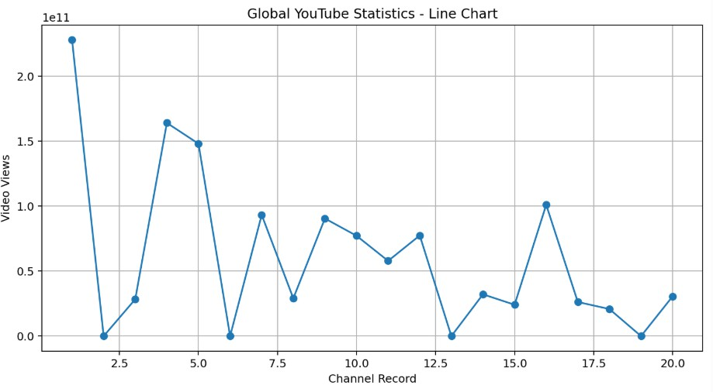

Output:

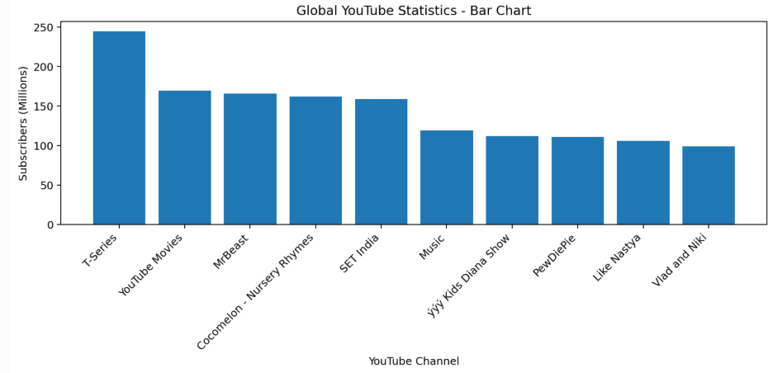

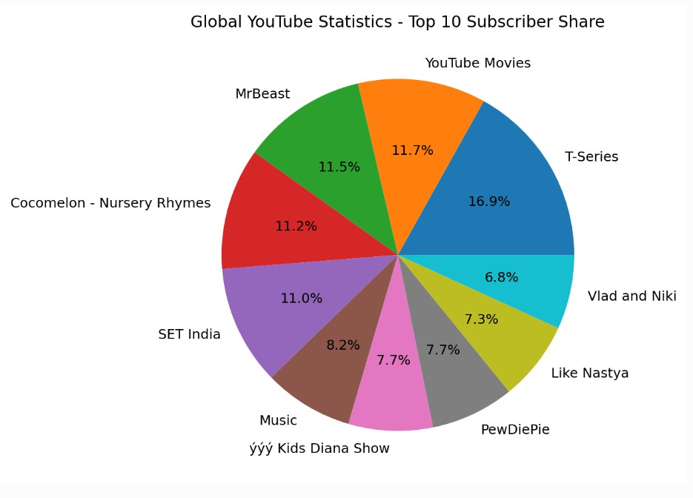

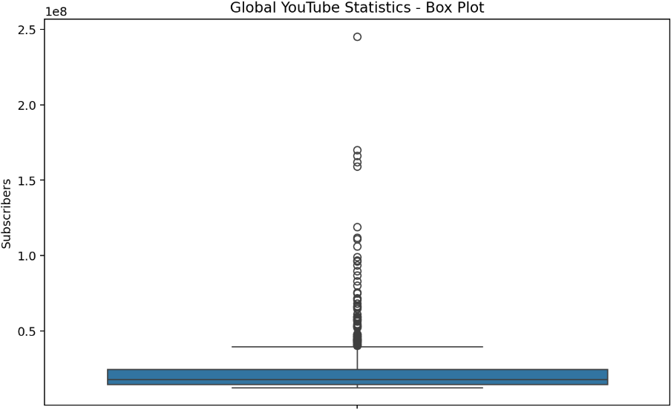

Result:

